
PB1/ENQP/1223/A 07-DEC-2023
PREBOARD EXAMINATION - I (2023-24)
Subject: ENGLISH (Core)  Grade: 12 |  | Max. Marks: 80  Time: 3 HOURS
Name: |  |  | Section: | Roll No:
General Instructions:
- This question paper consists of 11 printed pages.
- All answers to be written on the answer sheet provided.
- Maintain proper sequence while answering questions of a particular section.
 | SECTION A
 | Reading Comprehension -22 Marks
1 | Read the passage given below carefully and answer the questions that follow: |  |  |  | 12M
Like many people acting on the desire to eat healthy and local, Acropolis resident Eduardo Jimenez decided to plant a garden in his backyard. He tilled the soil, he planted the seeds, and he even erected a fence to keep out the deer. Eduardo did everything right. Or so it seems. Harvest time has come, and he has not one tomato, bean, or leaf of lettuce to show for his hard work. How did this happen? The answer comes in the form of a small, brown, particularly smelly insect: the stink bug.

Unlike their fastidious cousins, stink bugs feed on some 300 species of plants, including figs, mulberries, corn, and citrus fruits as well as soybeans, legumes, and weeds. Although they do little damage to the plant itself, they make the fruits and vegetables unmarketable. For this reason, stink bugs pose the most serious threat to the big agriculturalists and macro farm operators. Macro farmers have more invested in their produce, and therefore have more to lose. While hobbyists like Eduardo are left to face the disappointment of an unsuccessful garden, macro farmers are forced to live with the loss of entire tracts of cash crops—a fact that has left many barely able to clothe their children or put food on the table. Last season alone, several New Jersey pepper farmers saw 75% of their crops damaged. Pennsylvania lost half of its peach population, and, according to the US Apple Association, apple farmers in the mid-Atlantic states lost $37 million. This year could be worse.

As a result of this decline in the supply of fresh fruits and vegetables, shoppers have seen adjustments—sometimes quite dramatic—in prices at the grocery store. Prices of apples in Maryland are up 8%. In the north-Atlantic states, prices for peppers shot up an astounding 14%. Not only are these items becoming more expensive, but they are also getting harder to find. Last week, Marge Jenkins of Athens, Georgia reported having to check three different stores before stumbling upon a decent batch of peas. And this, she assures us, is a regular occurrence.

Accidentally brought from Asia, the stink bug has no natural predators in America, and thus its population is soaring. Reported sightings of stink bugs are becoming increasingly numerous, as the desiccated, brown, trapezoidal shells of the dead bugs are ubiquitous in some areas. This has farmers and scientists alike scratching their heads in search of a remedy. Hope, they believe, may lie with an Asian parasitic wasp, which helpfully lays its eggs inside stink bug eggs. The larvae of the wasp devour the stink bug from the inside. Implementation of such a solution is still several years away, as scientists must first determine if it is safe for the wasp to be introduced into America. Until then, some farmers are resorting to homemade traps. Others have even contemplated the use of peacocks and praying mantises, which, they hypothesize, will gulp down the little stinkers.
1. | Based on your understanding of the above passage, answer each of the questions given below by choosing the most appropriate option. |  |  |  | 1x12=12
i. | 1) It is typically a good idea to begin a new paragraph with a transition sentence. Transition sentences are used to introduce a new idea, and to make a smooth shift from the previous paragraph to the next. This helps prevent the reader from getting lost or confused. Using this information, which of the following is the best transition sentence to insert at the beginning of paragraph 2?  - An increasing number of them have been found in North America, occupying over half of the continental United States as well as Mexico and parts of Canada.  - Unbeknownst to Eduardo, the local population of stink bugs has increased dramatically over the last decade, especially in and around the town of Acropolis.  - A member of the Pantatomidae family, stink bugs surprisingly do not share the eating habits of related insects.  - Brown marmorated stink bugs, which first appeared in America in the late 1990s, are now found in over 30 states.
ii. | Based on its use in paragraph 2, it can be inferred that fastidious belongs to which of the following word families?  - forward, assertive, proactive  - demanding, particular, critical  - delicate, insubstantial, frail  - passionate, fervent, avid
iii | In paragraph 2, the author most likely refers to people like Eduardo as "hobbyists" in order to  - illustrate the type of person who plants a home garden  - characterize the type of person who is most likely to be affected by stink bugs  - emphasize the idea that gardeners are relatively unskilled compared to farmers  - juxtapose the impact of stink bugs on gardeners with that on farmers
iv. | According to the author, what is the biggest problem resulting from stink bugs?  - Fresh fruits and vegetables are becoming harder to find.  - Peppers and apples are becoming increasingly scarce.  - The price of fresh fruits and vegetables is increasing.  - Macro farmers are losing their crops.
v. | Based on the information in paragraph 3, it can be inferred that an increase in supply results in  - a decrease in price  - an increase in demand  - low availability  - reduced importance
vi. | Which of the following statements would the author most likely agree with?  - The fight against stink bugs is hopeless.  - There is a possible remedy to the stink bug problem, but it is unlikely to succeed.  - In hopes of eradicating stink bugs, several solutions are in the works.  - While the stink bug problem is difficult, most believe it to be short-lived.
vii. | Using the passage as a guide, it can be understood that  I. Macro farmers commonly use pesticides, artificial hormones, and other synthetic materials.  II. Until a solution to the stink bug problem is found, it is probably not a good time to start a home garden in Washington DC.  III. Introducing foreign insects to closed environments can cause hazardous imbalances.  - I only  - II only  - I and II only  - II and III only
viii | As used in the final paragraph, which of the following describes something that is ubiquitous?  - On Friendship Day, our school was littered with little sticky notes. I even found one stuck to my shoe when I got home.  - Ignacio counted eight purple trucks on the way to work today. He is in the market for a new truck and would like to get a color that nobody else already has.  - The copier malfunctioned and showered paper all over the room. It took Earnest twenty minutes to clean it up.  - Upon taking the hot dogs from the fire, flies swarmed the campers. Jaime wished he had brought bug spray.
ix. | Choose the BEST statement:  - the stink bug has natural predators but not in America  - the stink bug has no natural predators in America which leads to its soaring population  - the stink bug has no natural predators in the world , so its population is soaring  - the stink bug has natural predators around the world
x. | Choose the word most similar in meaning to the word printed in bold, as used in the passage.  desiccated  - Shred  - Cut  - Dry  - Grated
xi. | Choose the appropriate solution to control the Stink Bug  - Use of wasps only can reduce the stink bug  - Peacocks and wasps can swallow them up  - Praying Mantis is the only solution  - Wasps, peacocks and Praying Mantis may solve the issue
xii. | Suggest a suitable title to the given passage.
2. | Read the passage carefully and answer the questions below- |  |  |  | 10M
Nestled in the heart of the azure ocean, surrounded by crystal-clear waters and adorned with lush greenery, the island of Serenity Cove beckons travelers seeking an unparalleled escape. This hidden gem promises an unforgettable experience, blending natural wonders, cultural richness, and a myriad of recreational activities. Let's embark on a virtual journey to discover the enchanting allure of Serenity Cove.
Serenity Cove is a haven for nature enthusiasts, boasting pristine beaches, dense tropical forests, and breathtaking coral reefs. The island's diverse ecosystems provide a habitat for a wide array of flora and fauna, making it a paradise for wildlife enthusiasts and photographers alike. Visitors can explore nature reserves, where the air is filled with the melodic symphony of exotic birds and the vibrant colors of butterflies dance through the sunlit forest canopies.
Beyond its natural beauty, Serenity Cove is steeped in a rich cultural tapestry. The island is home to a warm and welcoming local population, eager to share their traditions and stories with curious travelers. Visitors can immerse themselves in the vibrant local markets, where handcrafted souvenirs and traditional delicacies reflect the island's unique heritage. Additionally, cultural festivals and performances provide a glimpse into the islanders' vibrant way of life.
For the adventure seekers, Serenity Cove offers a plethora of recreational activities. From water sports such as snorkeling and scuba diving to hiking trails that lead to panoramic viewpoints, there's something for every thrill-seeker. The island's coastline is dotted with hidden coves and secluded lagoons, perfect for those seeking tranquility or a romantic escape. The coral reefs surrounding the island beckon divers to explore a kaleidoscope of marine life, creating memories that last a lifetime.
Serenity Cove provides a range of accommodations, from luxurious beachfront resorts to cozy eco-friendly lodges nestled in the heart of the jungle. Each option offers a unique experience, blending modern comforts with the island's natural charm. As for cuisine, the island's culinary scene reflects a fusion of local flavors and international influences. Fresh seafood, tropical fruits, and aromatic spices tantalize the taste buds, ensuring that every meal is a gastronomic delight.
In conclusion, Serenity Cove stands as an idyllic destination, seamlessly combining natural wonders, cultural richness, and a spectrum of recreational activities. Whether seeking relaxation on the pristine beaches, immersion in the island's vibrant culture, or thrilling adventures, Serenity Cove caters to the diverse tastes of every traveler. Pack your bags, and let this island paradise weave its magic on you.
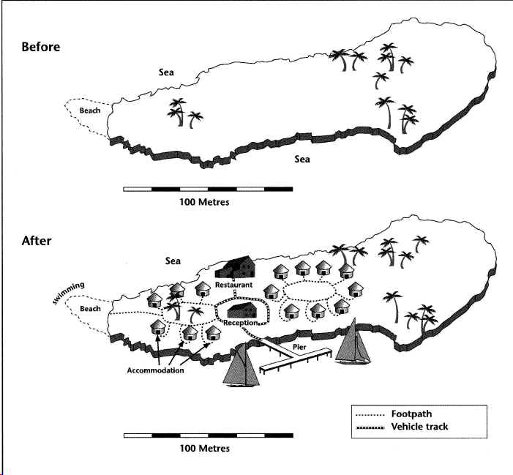
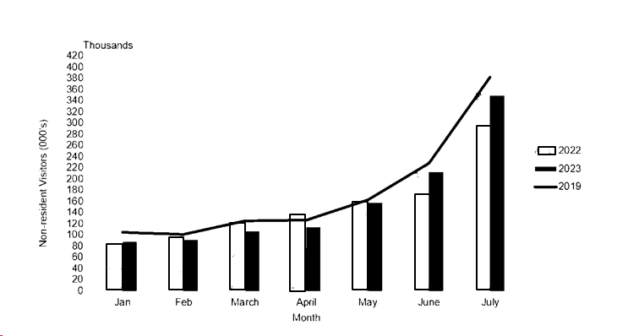

2 | Based on your understanding of the above passage, figure and data, answer each of the questions given below by choosing the most appropriate option. Attempt all questions. |  |  |  | 1x10=10
i. | What makes Serenity Cove a haven for nature enthusiasts?  - Dense urban landscape  - Pristine beaches, tropical forests, and coral reefs  - High-rise buildings and skyscrapers  - Arid deserts and rocky terrain
ii. | The cultural richness of Serenity Cove?  - Local markets, handcrafted souvenirs, and traditional delicacies  - Modern shopping malls and international fast-food chains  - High-tech museums and virtual reality exhibits  - Imported goods and luxury brands
iii. | The non- resident visitors over the past 3 years show (based on the graph)  - Erratic trends  - Similar trends  - Highs and lows  - Not able to make out
iv. | Pick the BEST option from the following statements (refer to the Island plan)  - The Island development was done in an organized manner  - The full Island was developed for tourism  - One- third of the Island was left wild and untouched  - There are footpaths and vehicle tracks throughout the Island
v. | What recreational activities are mentioned for thrill-seekers on the island?  - Snorkeling, skiing and snowboarding  - Snorkeling, scuba diving, and hiking  - Board games, Indoor gaming and movie marathons  - Shopping and spa treatments
vi. | If one is not interested in any adventerous activities, they can still opt for  - Using the Island gymn  - Watching TV  - Go walking around the Island  - Go skiing
vii. | What type of accommodations are available on Serenity Cove?  - Only beachfront resorts  - Only eco-friendly lodges in the jungle  - A range of options, from luxurious beachfront resorts to eco-friendly lodges  - Basic camping facilities only
viii. | One of the attractions for wildlife enthusiasts on the island is the Nature reserves with diverse flora and fauna  Flora and fauna means …………………………& …………………………
ix. | What is mentioned as a hidden feature of the island's coastline?  - Hidden coves and some Crowded tourist spots  - Hidden coves and secluded lagoons  - Hidden stars  - No coastline attractions
x. | Serenity Cove is a haven for nature enthusiasts. The following sentences use the word ‘haven’. Pick the sentence that has used the word ‘haven’ inappropriately.  - These days the port is mainly used as a haven for small fishing boats.  - The island's tax regulations are so lax that it has become a haven for owners of offshore companies  - They wanted to provide a safe haven for the refugees  - Being spiritual will elevate one to haven.
 | SECTION B
 | Creative Writing Skills-18 Marks
3.A | Your school has planned to organize a summer camp for students of the age group 10-12 years to develop their creative skills in art, craft, clay modelling, music, etc., in your school during the summer vacation in the month of May. Draft a notice for your school notice board inviting applications from expert students, preferably from grade 11 and 12, who would be willing to take some classes. Mention the required qualification and the last date of application and any other details you would like to furnish. You are Preeta/Ravi, Cultural Secretary, DAV Public School, Raipur. |  |  |  | 4
 | OR
B. | The successful journey of Chandarayaan-3 encapsulates within itself grit, ambition, initiative, scientific temper, curiosity, problem solving and creativity – qualities that education across grades strives to instil and achieve. The MyGov platform is celebrating the success of this mission through ‘Chandrayaan-3 Maha Quiz’. You are requested to disseminate the above information among the students of your school through a Notice and encourage maximum number of students to participate in this quiz, providing more details. You are the Raju / Rama, CBSE coordinator of your school, Rishi Valley Academy, Ooty.
4.A | The Indian Physical Education Institute is planning a course for all PE teachers, to explore how sports can seamlessly integrate with academics, fostering interdisciplinary learning and personal growth. As the organizing body and host, urge the Principals of various schools to encourage their PE teachers to join the course and reap benefit out of it by giving relevant reasons. The name of the course is – ‘Mapping PE to all subjects’ Draft an invitation as the Chief Education Officer of the Institution inviting Principal’s to depute their PE faculty. |  |  |  | 4
 | OR
B. |   You are Dr. Ismail Serageldin, Director, The Library of Alexandria, and you have received this invitation. Respond to the invitation with your consent in about 50 words.
5.A |   In spite of all works being done to save the environment, there are still areas where people continue to remain to be insentive towards the environment. Some beaches still are abused and it makes it a nightmare to take your kids there during weekends. As a responsible citizen, write a letter to the Editor of the newspaper – Deccan Herald, referring to a particular beach that requires monitoring and offering some concrete solutions to improve it. You are Harish / Harini – a professional, parent and an environmentalist. |  |  |  | 5
 | OR
B. | You are Arun / Aruna from Bangaluru, staying at 204, 4th Cross, Jaynagar, Bangaluru. You see an advertisement in The Hindu and wish to apply for the same. Pick any one suitable job and apply for the same.  Volunteer Hospitality Teacher  A non-profit organization established in Africa is looking for a candidate who would be highly interested to volunteer in teaching Housekeeping and Front Office (in English or in French) remotely and via Zoom to students ages 18-24. If you are interested, please submit in your CV and we can discuss further.  Job Types: Full-time, Part-time- Part-time hours: 2 per week  Experience: • teaching: 1 year (Preferred)  License/Certification: • teaching experience (Preferred)  Apply to the Managing Director, Teach for Africa, Skills and Empowerment Institute, Harvey Road, South Africa.  Manager- Editorial & Advertisement  Responsibility: Develop and manage the magazine's content and advertisement strategy, ensuring a blend of editorials, interviews, health tips, and brand placements. Collaborate with design, editorial, and retail team to produce and circulate the printed and digital magazine each month/bi-monthly Cultivate relationships with industry experts for content contributions and with brands for advertising opportunities.  Apply with CV to CEO, Life Pharmacy, Head Office, Link Road, Santa Cruz, Mumbai. Alternately you may apply to ceo@lifepharmacy.com
6.A | As a part of wellness and keep fit vision, your school has organized a wellness and fitness camp. It is a two-hour weekly session to help students develop confidence and resilience.  Write an article in 120-150 words for the school magazine giving reasons why a wellness camp is crucial for students these days. Also give some details of the camp held in your school outlining some programs, skills developed and how these could help students to cope with stresses and anxieties. |  |  |  | 5
 | OR
B. | Read the following extract from a poster found on ‘India Running’website  Experience Gujarat's renowned hospitality and the unwavering spirit of Indian Navy- INS VALSURA, all in one exhilarating race - THE SAURASHTRA NAVY HALF MARATHON 2023, where you can stride side by side with the brave and resilient members of our Defence Forces. Choose Your Challenge : Half Marathon / 10 Km Timed Run / 5 Km Fun Run. Venue: Lakhota Lake, Jamnagar  You are not only a participant, you are also a reporter to the local newspaper Gujarat Times. As a reporter, write a report in 120-150 words on the Marathon that was held on 19th November 2023 giving necessary details.
 | SECTION C
 | Literature 40 Marks
7. | Read the poem extracts given below and answer the questions that follow. Attempt 1 out of 2 extracts. |  |  |  | 1x6=6
A. | Aunt Jennifer’s fingers fluttering through her wool  Find even the ivory needle hard to pull.  The massive weight of Uncle’s wedding band  Sits heavily upon Aunt Jennifer’s hand.
a | What is Aunt Jennifer doing?
b | Identify any one figure of speech from the above lines.
c | Why is the ivory needle hard to pull?
d | What is the emotion one can sense through the word ‘fluttering’?
e | How is the juxtaposition of the ‘ivory needle’ to the ‘massive weight’ indicative of the same theme / issue?
f | Name the poem and the poet of the above lines.
 | OR
B. | Of all the thousand selfish cars that pass,  Just one to inquire what a farmer’s prices are.  And one did stop, but only to plow up grass  In using the yard to back and turn around;  And another to ask the way to where it was bound;  And another to ask could they sell it a gallon of gas  They couldn’t (this crossly); they had none, didn’t it see?
a | Name the poem and the poet of the above lines.
b | ‘Just one to inquire …..are’. Did the car stop? Give reasons to your answer.
c | Explain the line ‘but only to plow up grass’.
d | Who is expecting the cars to stop and why?
e | Identify one figure of speech from the above lines.
f | The last two lines given above uses ‘it’ (as in sell it , didn’t it). What according to you is ‘it’? Give reasons as to why the poet is using ‘ít’ here?
8. | Read the prose extracts given below and answer the questions that follow. Attempt 1 out of 2 extracts.
DERRY: I hate it here.
MOTHER: You can’t help the things you say. I forgive you. It’s bound to make you feel bad things....and say them. I don’t blame you.
DERRY: It’s got nothing to do with my face and what I look like. I don’t care about that and it isn’t important. It’s what I think and feel and what I want to see and find out and hear. And I’m going back there. Only to help him with the crab apples. Only to look at things and listen. But I’m going.
MOTHER: You’ll stop here.
DERRY: Oh no, oh no. Because if I don’t go back there, I’ll never go anywhere in this world again.
a | Why was Derry and his mother arguing?
b | Why did Derry’s mother feel that Derry was bound to ‘feel bad’
c | How does Derry reinstate his feelings of being independent and confident?
d | What do you understand by the statement – ‘I’ll never go anywhere in this world again’?
 | OR
“You say the man escaped?” the General asked faintly.
He had been operated upon a week before, an emergency operation to which Sadao had been called in the night.
a | What was the operation for? How long did it take Sadao to realize that the General would survive?
b | Who is ‘the man’ that the General was speaking about?
c | What did the General’s promise Sadao before the operation?
d | How did the man escape? Explain.
9. | Read the prose extracts given below and answer the questions that follow. Attempt 1 out of 2 extracts. |  |  |  | 1x6=6
A. | This settlement was adopted unanimously by the commission. Gandhi explained that the amount of the refund was less important than the fact that the landlords had been obliged to surrender part of the money and, with it, part of their prestige.
a | What was Gandhi negotiating?
b | Gandhi asked for a 50% refund instead of a full refund. Finally, how much did Gandhi settle for?
c | How did the planters and peasants react to the settlement?
d | The planters had to give up on two aspects – what were they?
e | Where did this incident take place? Who was the primary instigator who brought the exploitation of sharecroppers to Gandhi’s attention?
f | The above event, in this part of the text, illustrates Gandhi’s method of working.  What are the skills he used and how can you link it to his ideas of satyagraha and  non-violence?
 | OR
B. | I used every way I knew to overcome this fear, but it held me firmly in its grip. Finally, one October, I decided to get an instructor and learn to swim. I went to a pool and practiced five days a week, an hour each day. The instructor put a belt around me. A rope attached to the belt went through a pulley that ran on an overhead cable.
a | Who is protagonist ‘I’ here? In what capacity was he associated with Franklin D. Roosevelt?
b | What was the earliest incident that caused fear in the protagonist?
c | What were the emotions felt by the writer when he was pushed into the pool?
d | What was the purpose of the rope in learning to swim?
e | Did the writer finally master swimming? How long did it take him?
f | Roosevelt said, “All we have to fear is fear itself.” How does this statement relate to the writer and his experience?
10. | Answer any five of the following questions in 30-40 words each: |  |  |  | 5x2=10
 | - How do you know that ‘Linguistic Chauvinism’ was exerted in Alsace, France?
 | - John Keats describes beauty found in both simplicity as well as grandeur. Give an example of each as given by the poet
 | - The naivety of the crofter is source of temptation trap to the peddler. Explain
 | - How will keeping quiet enable us to take a step towards peace?
 | - What was Firozabad famous for? What are the forces that strangle the city to remain in constant poverty?
 | - Interviews are mostly hated. Give two examples of how interviews are despised by some famous people.
11. | Answer any two of the following questions in 30-40 words each: |  |  |  | 2x2=4
 | - Why was Student on Ice program successful?
 | - What did the Maharaja do to find the required number of tigers to kill?
 | - Where did Sam disappear? How did Jack Finney realize where he was?
12. | Answer any one of the following questions in about 120-150 words: |  |  |  | 5
A. | ‘Poets and Pancakes’ is a beautiful example of humour in its chatty and rambling style’. Comment.
 | OR
B. | Umberto Eco, in his interview points out about himself, his writing style and his novel. Comment on the same giving details.
13. | Answer any one of the following questions in about 120-150 words: |  |  |  | 5
A. | Dr. Sadao is swayed between his role as a doctor and that of a patriotic citizen. In this dilemma, which role came out stronger or weaker? Give reasons
 | OR
B. | Bama’s and Zitkala-Sa’s life stories are a reflection of discrimination from very different cultures and societies. Imagine you are Zitkala-Sa. Write a letter to Bama, giving details of the ordeal you went through. Use a clear letter format.
***

